**WITH NOISE AND WITHOUT FILTER FUZZY**

**Image set:**

|  |
| --- |
| **Image 1:-0.1 % Noise** |

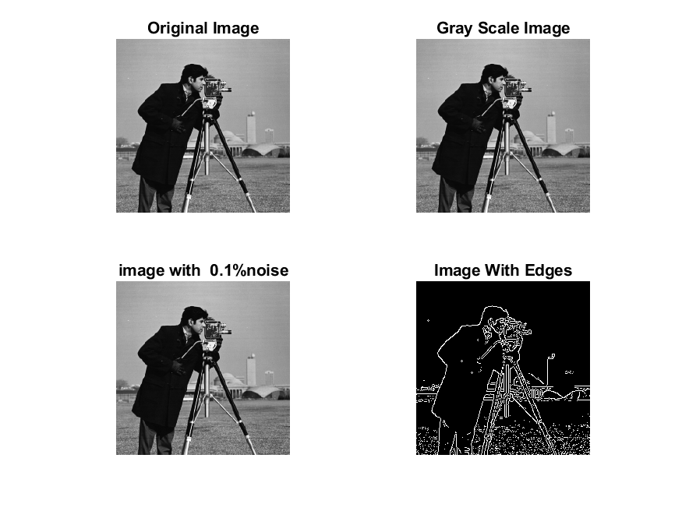

**Image 2:-10 % Noise**

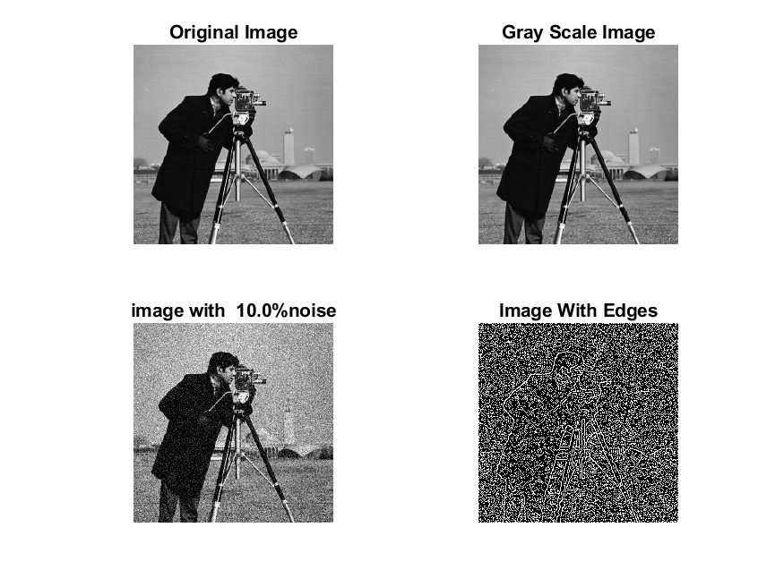

**Image 3:-20 % Noise**

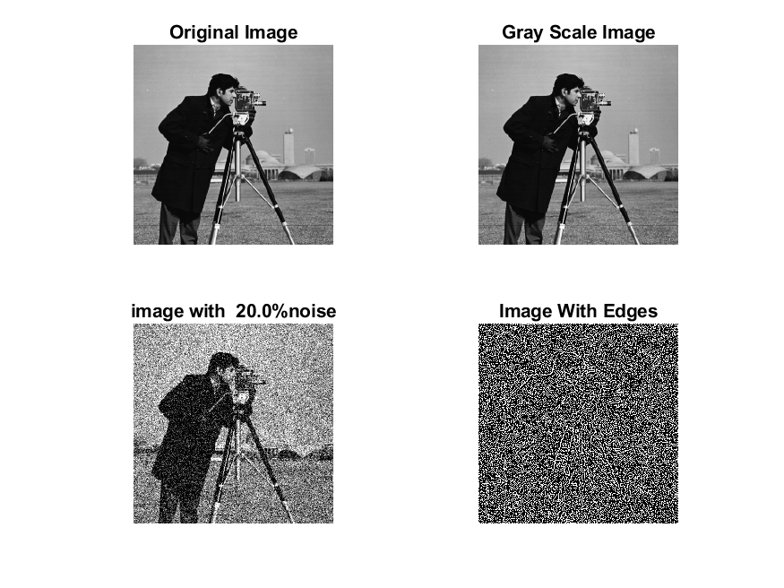

**Image 4:-30 % Noise**

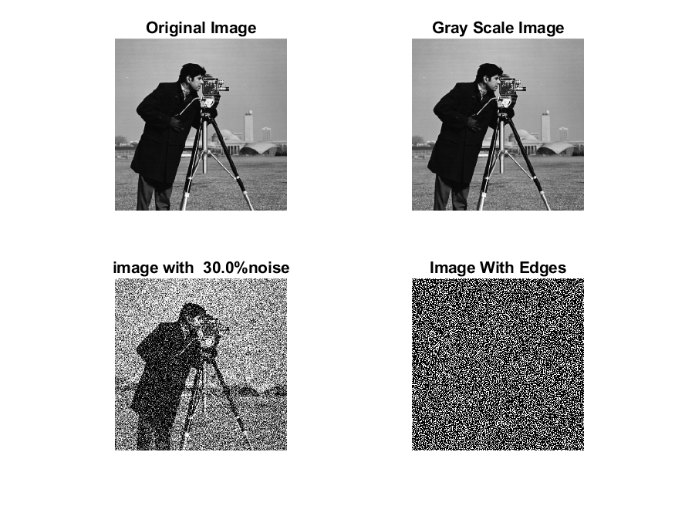

|  |
| --- |
| **Image 5:-40 % Noise** |

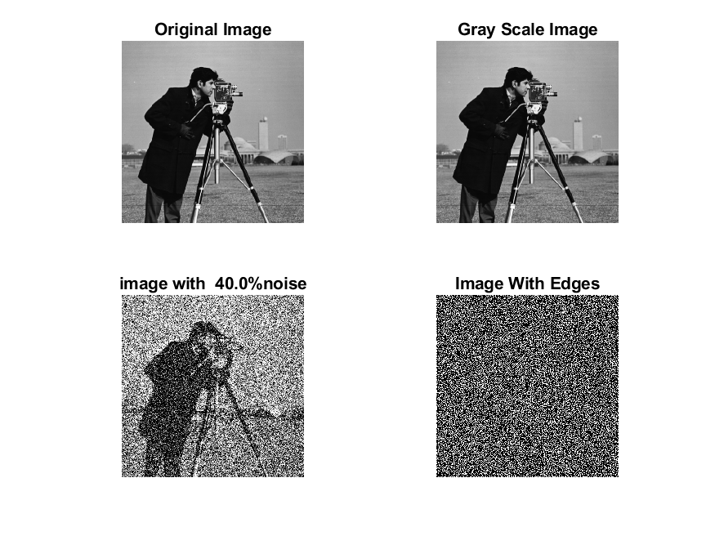

**Image 6:-50 % Noise**

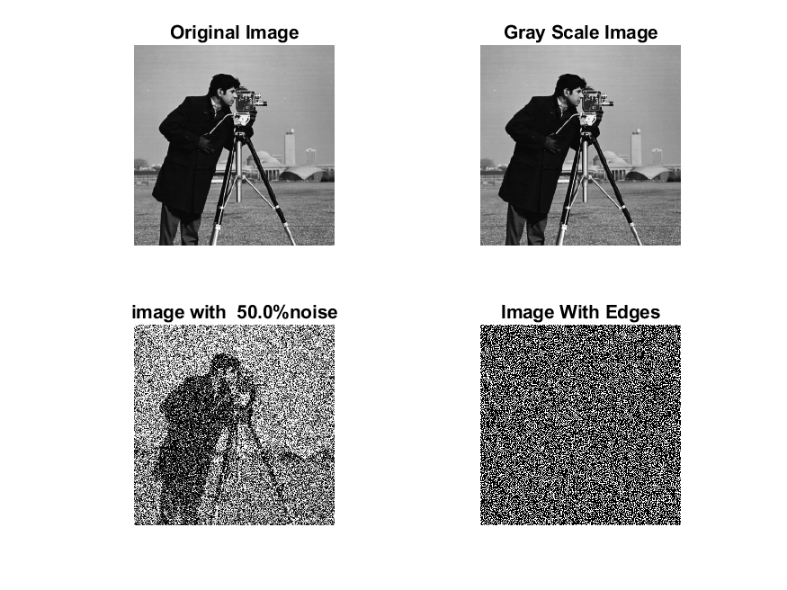

**Image 7:-60 % Noise**

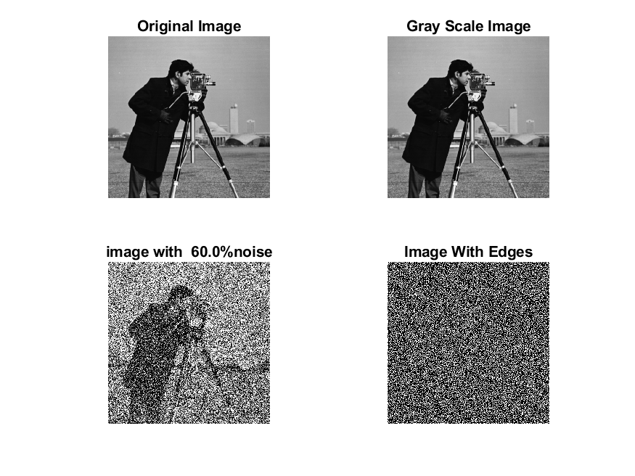

**Image 8:-70 % Noise**

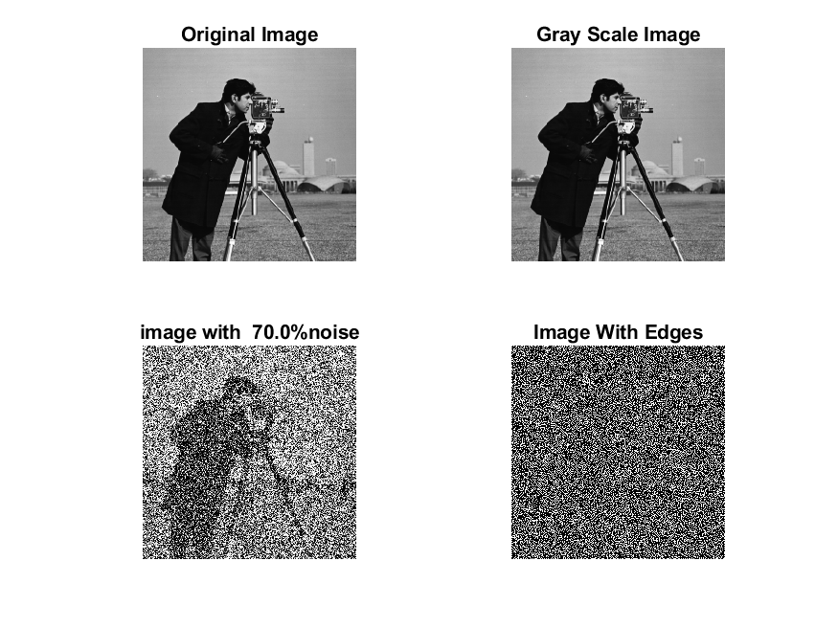

**Image 9:-80 % Noise**

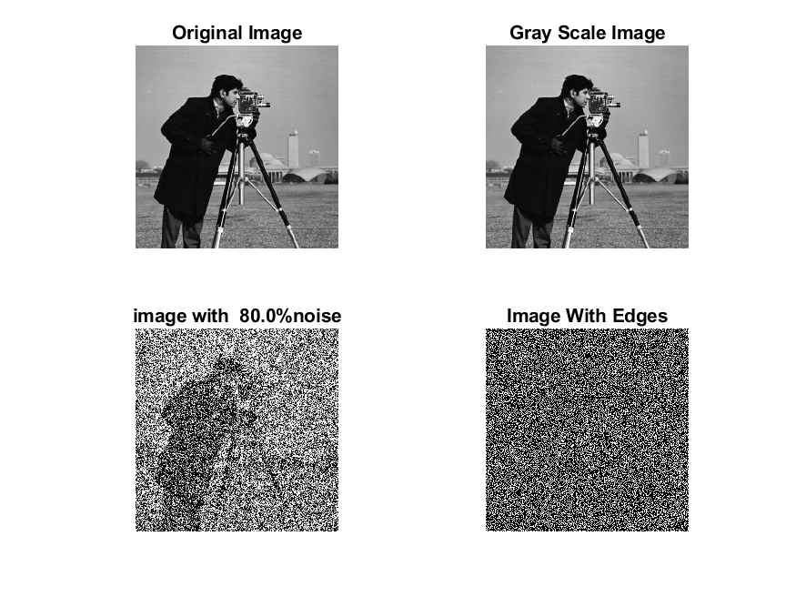

**DATA FILES**

**Image 1:-Noise0.1**

Original image ideal values:

IM1 image entropy:4.025185e-01

IM1 image mean:0.080096

Ground truth image entropy:0.717315

Ground truth image mean:0.197705

entropy between imt and im1 :0.650583

MSE between imt and im1 :0.216207

Average Difference between imt and im1 :0.117609

Maximum Difference between imt and im1 :1.000000

True Positive values:1573.000000

False Positive values: 2518.000000

True Negative values:38460.000000

False Negative values:8525.000000

Accuracy value: 0.783793

F Measure values:0.221721

Peak Signal-to Noise Ration value: 6.651298

Signal-to Noise Ration value: -3.924059

percentage of pixels that were correctly detected (Pco): 0.155773

The percentage of pixels that were not detected (Pnd):0.844227

the percentage of false alarm: (Pfa):0.249356

Euclidean Distance Value :14.628358

**Image 2:-Noise10**

Original image ideal values:

IM1 image entropy:8.759667e-01

IM1 image mean:0.295697

Ground truth image entropy:0.717315

Ground truth image mean:0.197705

entropy between imt and im1 :0.585231

MSE between imt and im1 :0.378749

Average Difference between imt and im1 :-0.097991

Maximum Difference between imt and im1 :1.000000

True Positive values:2928.000000

False Positive values: 12175.000000

True Negative values:28803.000000

False Negative values:7170.000000

Accuracy value: 0.621251

F Measure values:0.232372

Peak Signal-to Noise Ration value: 4.216481

Signal-to Noise Ration value: 1.748279

percentage of pixels that were correctly detected (Pco): 0.193869

The percentage of pixels that were not detected (Pnd):0.474740

the percentage of false alarm: (Pfa):0.806131

Euclidean Distance Value :18.434308

**Image 3:-Noise20**

Original image ideal values:

IM1 image entropy:9.178580e-01

IM1 image mean:0.332896

Ground truth image entropy:0.717315

Ground truth image mean:0.197705

entropy between imt and im1 :0.565338

MSE between imt and im1 :0.400991

Average Difference between imt and im1 :-0.135191

Maximum Difference between imt and im1 :1.000000

True Positive values:3310.000000

False Positive values: 13693.000000

True Negative values:27285.000000

False Negative values:6788.000000

Accuracy value: 0.599009

F Measure values:0.244271

Peak Signal-to Noise Ration value: 3.968657

Signal-to Noise Ration value: 2.262902

percentage of pixels that were correctly detected (Pco): 0.194672

The percentage of pixels that were not detected (Pnd):0.399224

the percentage of false alarm: (Pfa):0.805328

Euclidean Distance Value :18.511881

**Image 4:-Noise30**

Original image ideal values:

IM1 image entropy:9.190120e-01

IM1 image mean:0.334051

Ground truth image entropy:0.717315

Ground truth image mean:0.197705

entropy between imt and im1 :0.564278

MSE between imt and im1 :0.401363

Average Difference between imt and im1 :-0.136346

Maximum Difference between imt and im1 :1.000000

True Positive values:3330.000000

False Positive values: 13732.000000

True Negative values:27246.000000

False Negative values:6768.000000

Accuracy value: 0.598637

F Measure values:0.245214

Peak Signal-to Noise Ration value: 3.964630

Signal-to Noise Ration value: 2.277946

percentage of pixels that were correctly detected (Pco): 0.195171

The percentage of pixels that were not detected (Pnd):0.396671

the percentage of false alarm: (Pfa):0.804829

Euclidean Distance Value :18.561561

**Image 5:-Noise40**

Original image ideal values:

IM1 image entropy:9.248030e-01

IM1 image mean:0.339984

Ground truth image entropy:0.717315

Ground truth image mean:0.197705

entropy between imt and im1 :0.559374

MSE between imt and im1 :0.403693

Average Difference between imt and im1 :-0.142278

Maximum Difference between imt and im1 :1.000000

True Positive values:3422.000000

False Positive values: 13943.000000

True Negative values:27035.000000

False Negative values:6676.000000

Accuracy value: 0.596307

F Measure values:0.249208

Peak Signal-to Noise Ration value: 3.939493

Signal-to Noise Ration value: 2.354394

percentage of pixels that were correctly detected (Pco): 0.197063

The percentage of pixels that were not detected (Pnd):0.384451

the percentage of false alarm: (Pfa):0.802937

Euclidean Distance Value :18.749906

**Image 6:-Noise50**

Original image ideal values:

IM1 image entropy:9.266459e-01

IM1 image mean:0.341922

Ground truth image entropy:0.717315

Ground truth image mean:0.197705

entropy between imt and im1 :0.559856

MSE between imt and im1 :0.405983

Average Difference between imt and im1 :-0.144216

Maximum Difference between imt and im1 :1.000000

True Positive values:3413.000000

False Positive values: 14051.000000

True Negative values:26927.000000

False Negative values:6685.000000

Accuracy value: 0.594017

F Measure values:0.247660

Peak Signal-to Noise Ration value: 3.914919

Signal-to Noise Ration value: 2.379084

percentage of pixels that were correctly detected (Pco): 0.195431

The percentage of pixels that were not detected (Pnd):0.382787

the percentage of false alarm: (Pfa):0.804569

Euclidean Distance Value :18.587075

**Image 7:-Noise60**

Original image ideal values:

IM1 image entropy:9.277511e-01

IM1 image mean:0.343097

Ground truth image entropy:0.717315

Ground truth image mean:0.197705

entropy between imt and im1 :0.556692

MSE between imt and im1 :0.404848

Average Difference between imt and im1 :-0.145391

Maximum Difference between imt and im1 :1.000000

True Positive values:3472.000000

False Positive values: 14052.000000

True Negative values:26926.000000

False Negative values:6626.000000

Accuracy value: 0.595152

F Measure values:0.251394

Peak Signal-to Noise Ration value: 3.927083

Signal-to Noise Ration value: 2.393979

percentage of pixels that were correctly detected (Pco): 0.198128

The percentage of pixels that were not detected (Pnd):0.378110

the percentage of false alarm: (Pfa):0.801872

Euclidean Distance Value :18.855946

**Image 8:-Noise70**

Original image ideal values:

IM1 image entropy:9.292473e-01

IM1 image mean:0.344702

Ground truth image entropy:0.717315

Ground truth image mean:0.197705

entropy between imt and im1 :0.555724

MSE between imt and im1 :0.405748

Average Difference between imt and im1 :-0.146997

Maximum Difference between imt and im1 :1.000000

True Positive values:3490.000000

False Positive values: 14116.000000

True Negative values:26862.000000

False Negative values:6608.000000

Accuracy value: 0.594252

F Measure values:0.251949

Peak Signal-to Noise Ration value: 3.917433

Signal-to Noise Ration value: 2.414253

percentage of pixels that were correctly detected (Pco): 0.198228

The percentage of pixels that were not detected (Pnd):0.375327

the percentage of false alarm: (Pfa):0.801772

Euclidean Distance Value :18.865797

**Image 9:-Noise80**

Original image ideal values:

IM1 image entropy:9.317281e-01

IM1 image mean:0.347404

Ground truth image entropy:0.717315

Ground truth image mean:0.197705

entropy between imt and im1 :0.555724

MSE between imt and im1 :0.408450

Average Difference between imt and im1 :-0.149698

Maximum Difference between imt and im1 :1.000000

True Positive values:3490.000000

False Positive values: 14254.000000

True Negative values:26724.000000

False Negative values:6608.000000

Accuracy value: 0.591550

F Measure values:0.250700

Peak Signal-to Noise Ration value: 3.888609

Signal-to Noise Ration value: 2.448162

percentage of pixels that were correctly detected (Pco): 0.196686

The percentage of pixels that were not detected (Pnd):0.372408

the percentage of false alarm: (Pfa):0.803314

Euclidean Distance Value :18.711975